**Primary use case base on the requirements:**

**Additional use case:**

1. Single pair bracket  
   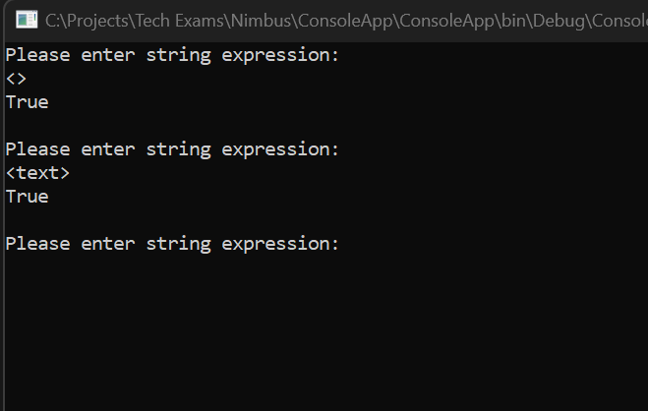
2. Unclose bracket.

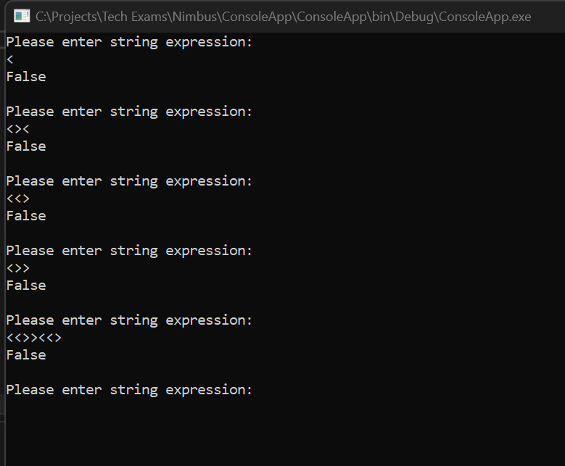

1. Multiple pair brackets.

Unit Test:

